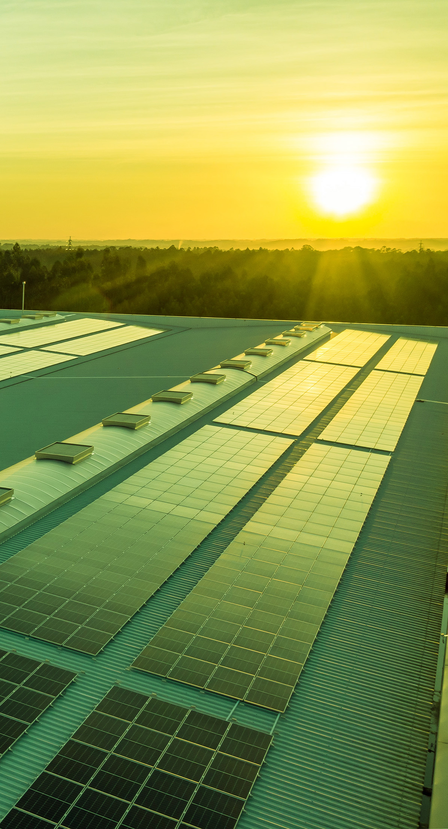chrisgreg

Solar on

Multifamily Affordable

Housing (SOMAH)

Program Triennial

Evaluation 2026

Research Plan

Prepared by:

Verdant Associates, LLC

DNV Energy Insights, Inc.

Verdant Associates, LLC

Berkeley, CA 94707

www.verdantassoc.com

February 13, 2025

Table of Contents

1 Introduction and Overview of Project 4

1.1 Program Background, Current Status, and Issues and Challenges it Faces to Achieving its Goals 6

1.2 Project Objectives and Overview of Approach 9

2 Evaluation Approach 11

2.1 Data Sources and Primary Data Collection Activities 12

2.2 Participation Assessment 26

2.3 Process Assessment 27

2.4 Impact Assessment 29

2.5 Cost-Effectiveness Assessment 36

2.6 Program Administration Assessment 38

3 Project Timeline 41

List of Figures

Figure 1‑1: Cumulative SOMAH Applications and Capacity Since Program Inception 7

Figure 1‑2: SOMAH Active Applications by Application Status, December 2022 vs. January 2025 7

Figure 1‑3: SOMAH 12-Year Forecast of Active and Complete Capacity, Through January 2025 9

Figure 1‑4: Primary Evaluation Objectives 9

Figure 2‑1: Impact Assessment Objectives and Approach 30

Figure 2‑2: PV Production Analysis 31

Figure 2‑4: Customer Energy Analysis Steps 33

Figure 2‑5: Bill Impact Measurements 35

Figure 2‑6: Program Administration Spending by Budget Category, 2020 through 2024 39

List of Tables

Table 1‑1: Annual Submitted and Cancelled/Withdrawn Applications, Paid Projects, and Cumulative Active and Paid Projects (as of 1/31/2025) 8

Table 1‑2: Assessment Area Objectives and Evaluation Approach 10

Table 2‑1: SOMAH Evaluation Data Needs 12

Table 2‑2: Summary of In-Depth Interviews and Surveys 19

Table 2‑3: Standard Practice Manual Cost-Effectiveness Tests 37

Verdant Associates, LLC (Verdant) and DNV Energy Insights Inc. (DNV) have been contracted by San Diego Gas and Electric’s (SDG&E) on behalf of the California Public Utilities Commission (CPUC) to evaluate the Solar on Multifamily Affordable Housing (SOMAH) program, as directed by California Public Utilities Commission (CPUC) Decision (D.) 17-12-022.[1] This document summarizes the approach for the 2026 triennial evaluation of the SOMAH program.

# Introduction and Overview of Project

Entering its 6th year since the first application was received, the SOMAH Program has continued to grow at a modest pace with nearly 34 MW of rebated capacity installed through January 2025. Prior evaluations found that the program delivers tangible benefits to tenants and building owners (e.g., bill savings) while providing grid benefits and reducing greenhouse gas emissions. However, despite this progress, the SOMAH program at its current pace is not on track to meet its goal of installing 300 MW of PV by 2032 (Figure 1‑3). The second triennial evaluation identified numerous challenges faced by the program:

* Participation has been burdensome and dominated by large affordable property owners (as of the last evaluation 69% of applications were submitted by 21 property owners) and one contractor.
* Tenant educational materials were not reaching SOMAH tenants resulting in tenant confusion over changes to their electric bills after the SOMAH-incentivized PV system was installed and interconnected.
* The observed solar PV production was below expectations with realization rates below 80%.
* The SOMAH program struggled with how to enable the resiliency benefits of battery storage within the construct of the program design and the SOMAH tariff.
* Community based organizations (CBOs) were struggling and in need of more training to effectively engage with and promote SOMAH to multifamily property owners.

But the SOMAH Program has not stood still – since the last evaluation, numerous changes have been implemented to remedy some of the challenges identified above. Close to 360 projects (50 MW) are in the incentive claim phase and will hopefully be completed within the next year. Program rules have been relaxed so that more buildings and project expenses are eligible for incentives and the program’s largest project developer is engaging subcontractors to further diversify the pool of program participants.

As the program continues to evolve, so do the evaluation needs. Below we highlight some of the new tasks for this evaluation that are incremental to prior SOMAH research:

1. **Marketing, Education, and Outreach (ME&O) Assessment.** We will conduct a deep dive into ME&O activities and trends, creating a roadmap of the SOMAH Program Administrator’s (PA’s) ME&O activities since 2020 to assess whether these activities have increased customer awareness of the program and influenced their decisions to participate.
2. **Cross-Program Data Analysis.** Leveraging DNV’s and Verdant’s insights from California energy efficiency, battery storage, financing, and electrification program evaluations, we will determine to what extent SOMAH participants (both property owners and tenants) are taking advantage of other programs for which they might be eligible.
3. **Job Training Surveys**. Surveys of job trainees (individuals who have fulfilled a SOMAH job training opportunity) can help to assess trainees’ experiences working on SOMAH projects, both in terms of skills or knowledge gained and ease of participation, and whether the SOMAH job training helped them secure longer-term employment within a clean energy field. We will also seek to determine trainees’ motivations for participating, and how their experience has impacted their interest in solar or other clean energy technologies and their future career path.
4. **Tenant interviews.** Tenant surveys will help assess tenant’s behavior and knowledge of the SOMAH program.
5. **Tax expert interviews.** These interviews will help us understand the evolving tax environment, tax credit options available for properties installing solar, battery storage, or electrification technologies, and optimal means for SOMAH participants to leverage available tax credits.

## Program Background, Current Status, and Issues and Challenges it Faces to Achieving its Goals

California State Assembly Bill (AB) 693 directed the CPUC to institute a new program intended to make qualifying solar energy systems more accessible to low-income and disadvantaged communities (DACs).[2] In December 2017, the CPUC issued Decision (D.) 17‐12‐022 creating the SOMAH Program and establishing program goals and eligibility requirements. The primary goals of this program are to install solar energy systems that have a generating capacity equivalent to at least 300 MW (CEC-AC) on qualified multifamily affordable housing properties through December 31, 2030[3] and to promote local economic development through job training requirements and hiring practices.

The SOMAH Program provides significant subsidies for the installation of solar photovoltaic (PV) systems on qualifying multifamily affordable housing properties. To qualify for SOMAH incentives, properties must be an existing residential multifamily deed restricted rental property having at least five units (including manufactured and mobile home properties) that have separately metered tenant units. The properties must also be located in PG&E, SCE, SDG&E, PacifiCorp, or Liberty service areas and meet at least one of the following recently expanded eligibility pathways: A) have at least 66% of households with incomes at or below 80% of the area median income, B) be located within a Disadvantaged Community (DAC)[4] C) be owned by a California Native American tribe, or D) be owned by a public housing authority or agency.

Figure 1‑1 below presents the SOMAH Program’s cumulative applications received and generation capacity since program inception. It also shows that to date 35% of all applications have been cancelled or withdrawn.

Figure 1‑1: Cumulative SOMAH Applications and Capacity Since Program Inception

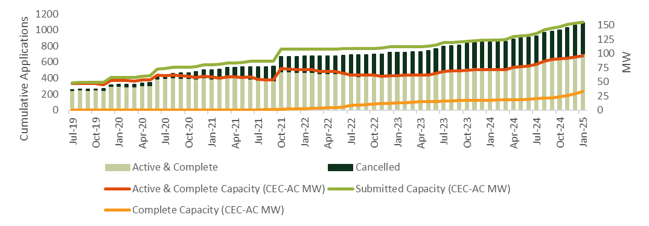

Figure 1‑2 below compares the number of active and completed (“Incentive Paid”) SOMAH applications as of the Second Triennial Report (left graphic) to the program’s current status (right graphic).[5] As this figure shows, in the two years since the last evaluation report, the number of completed projects has more than tripled (from 71 to 248) and the number of active projects (including completed) has gone up by 63%.

Figure 1‑2: SOMAH Active Applications by Application Status, December 2022 vs. January 2025

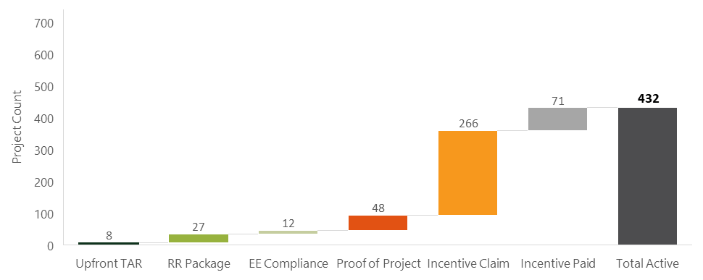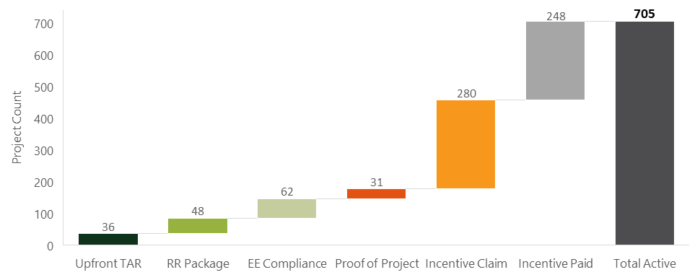

Table 1‑1 below shows the number of SOMAH applications that have been submitted, cancelled or withdrawn, and paid each year since the program’s inception. It also shows the cumulative number of active and paid projects by year. As this figure shows, currently 381 of the 1,086 submitted applications have been cancelled/withdrawn (35%) and 248 have been completed and received their incentive (23%).

Table 1‑1: Annual Submitted and Cancelled/Withdrawn Applications, Paid Projects, and Cumulative Active and Paid Projects (as of 1/31/2025)

|  |  |  |  |  |
| --- | --- | --- | --- | --- |
| Calendar Year | Submitted Applications | Cancelled or Withdrawn Applications | Paid Projects | Cumulative Active and Paid Projects |
| 2019 | 317 | 21 | 0 | 296 |
| 2020 | 183 | 74 | 0 | 405 |
| 2021 | 170 | 102 | 14 | 473 |
| 2022 | 49 | 94 | 57 | 428 |
| 2023 | 127 | 22 | 38 | 533 |
| 2024 | 210 | 59 | 103 | 684 |
| 2025* | 30 | 9 | 36 | 705 |
| Total | 1,086 | 381 (35%) | 248 (23%) | 705 (58%) |

*2025 is limited to applications through January 31, 2025

Figure 1‑3 below shows the 12-year forecast of active and completed project capacity based on SOMAH applications submitted through January 31, 2025. This forecast includes projections assuming participation continued at the same pace as program’s first, fourth, and sixth years, and the program average to date. As this figure shows, the only forecast in which the program achieves its 300 MW goal is if participation returned to the level it experienced during the first year of the program and remained at that level for the final six years of the program. The alternative forecasts (based on program performance in the fourth, sixth, and the average program year) show the program falling short of the 300 MW goal.

Figure 1‑: SOMAH 12-Year Forecast of Active and Complete Capacity, Through January 2025

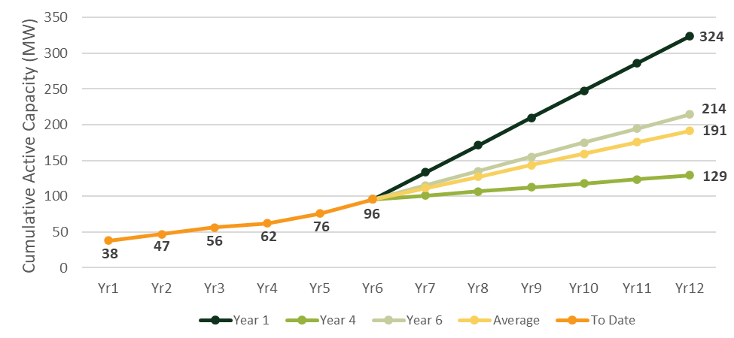

## Project Objectives and Overview of Approach

The primary objectives of SOMAH Program’s third triennial evaluation are presented in Figure 1‑4 below.

Figure ‑: Primary Evaluation Objectives

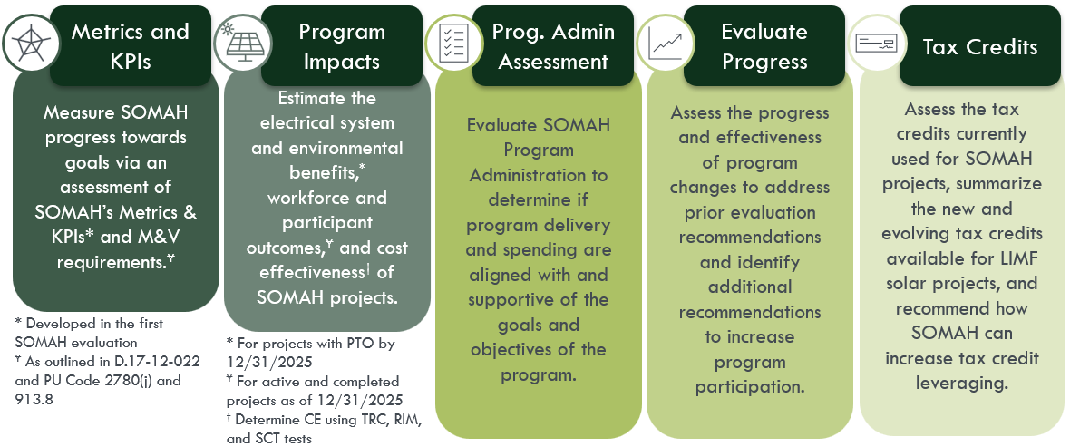

Below we provide a high-level overview of the evaluation approach based on the goals of the SOMAH Program, the program changes that have been implemented since the last SOMAH evaluation, and the objectives for this evaluation. Table 1‑2 presents the five primary assessment areas that cover the study’s research objectives and an overview of the approach to conduct each of these assessments.

Table 1‑2: Assessment Area Objectives and Evaluation Approach

|  |  |
| --- | --- |
| Assessment Area Objectives | Evaluation Approach |
| **Participation Assessment** to quantify and characterize SOMAH participation using metrics such as the number and size of installed projects, the location of homes served (and not served), eligibility pathway, contractor diversity, and program and project costs by system ownership. | Comprehensive analysis of various SOMAH data sources including application and project data stored in the PowerClerk program tracking database and the eligible contractor database maintained by the SOMAH PA. |
| **Process Assessment** to assess progress made towards minimizing identified barriers to participation, increasing the effectiveness of ME&O and WFD activities, implementing prior evaluation recommendations, and identifying areas where continued program improvements are needed. | Extensive primary data collection and analysis including:   * 50 in-depth interviews with the SOMAH PA, IOUs, participating and non-participating contractors and property owners, LIMF tax experts, and CBO and bridge financing partners * Hundreds of surveys with SOMAH tenants and job trainees * Program data from IOUs for other programs (EE, financing, battery storage, EV, etc.) leveraged by SOMAH properties and tenants |
| **Impact Assessment** to quantify SOMAH’s energy (kWh and kW), environmental (Greenhouse gas), and economic (tenant and common area bill savings and avoided costs) impacts. | **Energy:** PV simulation adjusted by performance ratios; Calculate utility energy and demand impacts using adjusted PV production.  **Environmental:** Estimate greenhouse gas reductions resulting from PV generation.  **Economic:** Calculate change in customer bills resulting from participants reductions in utility energy consumption; Estimate program impact on CARE budgets and customer arrearages. |
| **Cost Effectiveness Assessment** to determine SOMAH’s cost effectiveness using three California Standard Practice Manual tests. | Model cost-effectiveness of each completed SOMAH project using Verdant’s publicly vetted cost-effectiveness model (VER CAT), historical customer consumption, and PV simulation adjusted by performance ratios. |
| **Program Administration Review** to determine whether SOMAH’s program spending and administrative efforts are aligned with and supportive of SOMAH’s goals and objectives. | Conduct a longitudinal assessment of SOMAH’s monthly spending by entity (SOMAH PA, IOUs, CPUC), budget allocation area, and administrative expense category (PA, ME&O, WFD, TA).  Conduct a detailed review of SOMAH's 2020 to 2025 ME&O Plans and interview the SOMAH PA and CBOs to establish the programs strategy and goals for increasing awareness and influencing customer decision making. Document specific approaches to ME&O such as: leveraging CBOs, education and marketing campaigns, direct outreach to property owners or tenants. Analysis of tracking data and data collected from contractors, property owners, and tenants will test how well the program executed these plans. |

# Evaluation Approach

We have grouped the evaluation objectives into five primary assessment areas. These assessment areas include:

A **Participation Assessment** to quantify and characterize SOMAH Program participation across project attributes (such as project eligibility type, application status, PV system size and costs, etc.), program Metrics and KPIs, and M&V reporting requirements.

A **Process Assessment** to determine the effectiveness of SOMAH’s Marketing, Education, and Outreach (ME&O) and Workforce Development (WFD) activities, the tax credits that can be leveraged for LIMF solar projects, SOMAH’s progress implementing prior evaluation recommendations and other changes to reduce participation barriers, and areas where continued improvements are needed to help the program achieve its goals. The process assessment will also include a cross-program participation analysis to assess SOMAH tenant and property owner participation in other stackable programs.

An **Impact Assessment** to estimate PV production and the change in electricity consumption to quantify SOMAH’s energy (kWh, kW), environmental (greenhouse gas), and economic (tenant/common area bill savings, changes to arrearages, and CARE subsidy reductions) impacts.

A **Cost-Effectiveness Assessment** to determine the cost-effectiveness of the SOMAH Program using three California Standard Practice Manual tests.

A **Program Administration Assessment** to longitudinally assess SOMAH’s program administration spending and ME&O strategies to determine whether SOMAH’s implementation activities are aligned with and supportive of SOMAH’s goals.

Within each of these research areas we will also assess any progress that has been made by the SOMAH PA to address recommendations stemming from prior evaluation research and identify areas where further program improvements are needed to help increase program participation and achieve its goals.

## Data Sources and Primary Data Collection Activities

The third triennial evaluation will rely upon many data sources and primary data collection activities that will serve to gather the data necessary to support the five assessment areas. Table 2‑1 below presents the data needs for each assessment area.

Table 22‑1: SOMAH Evaluation Data Needs

|  |  |  |  |  |  |
| --- | --- | --- | --- | --- | --- |
| Data Collection Activity | Participation Assessment | Process Assessment | Impact Assessment | Cost-Effectiveness Assessment | Program Administrator Assessment |
| SOMAH Program Tracking Data | *X* | *X* | *X* | *X* |  |
| PV Performance and AMI Data |  | *X* | *X* | *X* |  |
| Program Administration Review Data |  | *X* |  | *X* | *X* |
| Response to Recommendations | *X* | *X* | *X* |  | *X* |
| SOMAH-Eligible Contractor and Property Owner Data | *X* | *X* |  |  | *X* |
| Job Trainee and Opportunity Data | *X* | *X* | *X* |  |  |
| Cross-Program Participation Data | *X* | *X* | *X* | *X* | *X* |
| **In-depth Interviews and Surveys** | ***X*** | ***X*** | ***X*** | ***X*** | ***X*** |
| SOMAH PA Interviews | *X* | *X* | *X* |  | *X* |
| Contractor and Property Owner In-  Depth Interviews and Surveys | *X* | *X* | *X* |  | *X* |
| CBO and Financing Org Interviews | *X* | *X* |  |  | *X* |
| Tax Expert Interviews | *X* | *X* | *X* | *X* |  |
| Tenant Surveys | *X* | *X* | *X* |  | *X* |
| Job Trainee Surveys | *X* | *X* | *X* |  | *X* |

#### SOMAH Program Tracking Data

A fundamental component for all aspects of the evaluation is the PowerClerk database that houses key applicant and system information for all SOMAH projects. This PowerClerk database will provide the following key elements necessary for the SOMAH evaluation:

* **SOMAH project information** such as application status (including the dates various project milestones were completed), project specs (system size, azimuth, tilt, etc.), system costs and SOMAH incentive, additional project funding (ITC, LIHTC), ownership type, and solar contractor information. These data will be used to assess program metrics and KPIs and to develop estimates of PV system energy production that can be compared to actual metered production for installed systems.
* **Applicant information** such as the applicant’s name and contact information (address, email, and phone) and property address that will be used to develop participating contractor and property owner survey samples and assess geographic distributions of participants.
* **Tenant beneficiary information** such as address, account/meter number, and Virtual Net Energy Metering (VNEM) allocation will allow our team to allocate generation credits and evaluate bill savings.

#### Performance (Generation) and AMI/Billing Data

Solar production and interval usage data will be used to quantify energy, environmental, and bill impacts. The SOMAH handbook states that a performance monitoring and reporting service (PMRS) is required to meter generation for each project and that all PV equipment be wired to a net generation output meter (NGOM). The PMRS often uses metrology built into the inverter and the NGOM is installed and operated by the utility. Verdant will request PV production data from both the NGOM and PMRS meters and beneficiary (tenant and common area) energy consumption and billing information. The combination of metered generation, pre- and post-installation energy usage, and billing information will enable Verdant to determine how systems are operating, estimate if beneficiaries are changing their electricity usage, and calculate beneficiaries’ saving on their electricity bills. These data will also be combined with grid information such as marginal emissions rates and utility and California Independent System Operator (CAISO) peak demand information to quantify environmental and grid benefits.

We will collect and validate the metered generation data of installed systems from the PMRS and NGOM data received. Validation activities will include identifying periods with no data or reduced generation due to system downtime, equipment failures, or a metering issue, to produce high quality generation data. These data will be used to evaluate the performance of installed systems relative to simulations of PV production produced from site level tracking and actual weather data. Verdant will also develop simulations of PV generation for installed and committed systems using typical meteorological year (TMY) weather data.

AMI data and billing information should be available for each customer and common area beneficiary. Verdant will request AMI and billing data for one year pre-and post-installation for beneficiaries living at sites with installed systems. These data will be used to determine if beneficiaries’ electricity consumption changes following the installation of the VNEM PV systems.[6]

Information on beneficiary customer utility rates (including CARE designation) and payment histories will also be requested for one year pre- and post-installation. The customer rate information will be used to develop estimates of customer utility bills and to determine how the installation of VNEM PV systems impacts their bills. Information on payment histories and potential arrearages will be analyzed to determine if SOMAH improves beneficiary utility bill payment and reduces arrearages.

###### IOU Data Request Timeline

The Verdant team will coordinate with the IOUs to collect the previously described Generation, AMI, and billing data based on the guidance and timelines contained in Primary Data Collection advice letters submitted by each IOU.[7] Given the timing of the evaluation, the Verdant team will issue **two data requests** to the IOUs for AMI/Billing data. The Verdant team intends for these two data requests to be identical (requested fields and structure), aside from the relevant time periods and project list. The intention behind the two data requests is to provide adequate time for the IOUs and evaluation team to address any potential data issues that arise after the first data request. The second data request will then be more streamlined, with fewer potential data issues, following the processes and protocols developed after the first request. This will allow the evaluation team adequate time to integrate the received IOU data into the final analysis.

The first data request will be issued in April 2025, covering the historical time period through the end of March 2025. The second data request will be issued in October 2025, for data from April 2025 through the end of September 2025. The second data request will be split into two parts: 2a will be for the extended date range on the same project list as request 1; 2b will be for the new projects that came online during the April to September 2025 time period.

###### SOMAH PA Data Requests

The most recent SOMAH evaluation revealed that several systems were underperforming, with an overall realization rate of only 77%. At that time, the SOMAH PA was developing a monitoring plan to flag underperforming systems and notify property owners and contractors. Verdant will request this monitoring data from the SOMAH PA, along with feedback from the SOMAH PA, property owners, and/or contractors, to continue to monitor and identify the root causes of system underperformance and develop recommendations to address these issues.

In the last evaluation, we estimated the time it takes from interconnection to bill credit setup. These were used as an approximation of when tenants would begin seeing SOMAH credits on their bills. The bill setup dates were compared to the PTO date to quantify the time to receive bill credits. In the previous evaluation we observed this wait period decreased from 2021 to 2022. We will continue to monitor the trend in this evaluation and request the bill setup dates from the SOMAH PA for this purpose.

###### Independently Acquired Data

The development of energy, economic, and environmental impacts will also require additional data that will either be requested from the utilities during the AMI/Billing data request or will be acquired independently. These data include the following:

* Weather data (TMY and actual) from the CALifornia Measurement Advisory Council (CALMAC)[8]
* Identification of the top IOU and CAISO 100 hours from CAISO’s Open Access Same-Time Information System (OASIS)[9]
* Greenhouse gas (GHG) emissions information from WattTime,[10] the California Air Resource Board (CARB), and the E3 Avoided Cost Calculator[11]

#### Program Administration Review Data

The data needed to complete the program administration review will include a mix of pre-existing data elements and primary data that will be collected as part of the evaluation research activities (these are further described in the In-Depth Interviews and Surveys section below). Some of the necessary pre-existing data elements are publicly availably (such as SOMAH’s annual Marketing, Education, and Outreach Plans and Semi-Annual Progress and Expense Reports). Other necessary data includes the SOMAH PA’s forecast and actual invoices from program inception through 2025 which will be requested from the SOMAH PA. These data will be used to assess program expenditures and uncommitted balances by program component, administrative spending by entity (each of the four members of the SOMAH PA, the five participating IOUs, and the CPUC), assess monthly spending by expense category (Program Admin, ME&O, WFD, and TA), compare labor vs. non-labor expenses, and estimate average program application processing costs.

#### Response to Recommendations (RTR) Tracking Workbook

Similar to the previous evaluation, Verdant will request the SOMAH PA’s RTR tracking workbook(s) to understand the progress they have made on past evaluation recommendations and to identify where additional changes are needed to help the program meet its goals.

#### SOMAH-Eligible Contractor and Property Owner Data

The SOMAH PA maintains a *contractor diversity database* that contains a listing of all SOMAH eligible contractors and data pertaining to their diversity status, size (number of employees), and experience (number of solar installations completed). As of the second triennial SOMAH evaluation, there were 153 unique contractors eligible to participate in the SOMAH Program, however only 14 had an active or completed program application. According to the SOMAH PA’s most recent Semi-Annual Progress Report (SAPR)[12] the number of SOMAH-eligible contractors as of December 31, 2024 has increased to 211, but only 20 contractors have submitted an application.[13] The Verdant team will request an update of this database from the SOMAH PA to assess the program’s progress with increasing the number and diversity of participating contractors (and subcontractors if they are included in the database). These data will also be used to identify eligible non-participating contractors for the contractor interviews described in the section below.

The SOMAH PA also maintains a *Salesforce database* of multifamily affordable properties located within SOMAH service territories that includes attributes for each property such as the number of tenant units, whether the property has an active SOMAH application, and if the property is located within a DAC. The Verdant team will request this database to characterize the differences between SOMAH eligible and participating properties. The PA also maintains a list of properties who have indicated interest in the program but have not yet participated (SOMAH email subscriber list). Both databases will be used to develop a sample frame for the non-participating property owner interviews for the evaluation.

#### Job Trainee and Opportunity Data and SOMAH PA Contractor Survey Data

The Incentive Claim Package requires each project to submit a Job Training Affidavit which includes job trainee contact information,[14] the types of tasks completed by the job trainees, the number of hours worked, the wages paid, and the job training program the trainee attended. This data, along with data on the number of job training opportunities created by the SOMAH Program, is tracked by the SOMAH PA and was analyzed as part of the second triennial SOMAH evaluation.

For this evaluation the Verdant team will request updates of all SOMAH job trainee data to determine whether there have been any notable changes to the tasks completed by job trainees, the types and lengths of SOMAH job training opportunities, and whether this training has led to beneficial long-term workforce outcomes. These data will also be assessed in combination with data collected during interviews with the SOMAH PA and CBOs and web surveys with job trainees to identify barriers to local hiring, track the progress made towards accomplishing SOMAH’s stated job training and hiring goals since the last evaluation, and report on SOMAH’s program metrics and KPIs related to workforce development.

#### Cross-Program Participation Data

A high-priority objective of the CPUC is to improve the integration (in terms of eligibility, participation, and data sharing) of programs targeting low-income and disadvantaged communities in California. D.17-12-022 includes the requirement for SOMAH projects to undergo energy efficiency audits and notify tenants about the availability of the IOUs’ Energy Savings Assistance (ESA) Program. As part of the Reservation Request Package, SOMAH applicants are required to submit a list of all tenant addresses that can be shared with the IOUs and used for ESA Program referrals. The previous two SOMAH evaluations were unable to verify if the IOUs had conducted any ESA Program outreach with SOMAH tenants, as the SOMAH PA had not received any data from the IOUs to verify cross-program outreach and participation (these data can be requested by the SOMAH PA annually).

To support the estimation of cross-program participation levels in this evaluation, the Verdant team will request program tracking data from the IOUs for programs that target low-income or DAC populations that SOMAH participants (contractors and tenants) are likely to have participated in.[15] Tenant surveys will be used to assess tenants’ awareness of the ESA Program and whether they installed any ESA Program measures in their homes since the SOMAH project was completed at their property. Participating SOMAH property owners will also be interviewed about other EE, DR, or DER programs they or their tenants have participated due to their participation in SOMAH. SOMAH PA and IOU interviews will be used to identify any current efforts to enroll SOMAH tenants or property owners in other energy saving programs.

#### In-Depth Interviews and Surveys

To better understand current SOMAH Program participation experiences, the impact program changes have had on reducing application burden and barriers to participation, and the effectiveness of current ME&O and WFD activities, the Verdant team will complete a number of data collection efforts with key participants and stakeholders. Table 2‑2 below provides an overview of the in-depth interview (IDI) and web survey data collection activities and the primary research objectives for each effort. The sample sizes were estimated by the Verdant team based on recently obtained publicly available data and data included in the second triennial SOMAH evaluation report. The available sample and number of completes may change based on analysis of SOMAH program tracking data. For all primary research activities, our team will increase the cultural competency of our research by seeking feedback from a member or organization from the targeted audience and ensuring the data collection instruments are offered in the primary languages of these audiences.

The Verdant team will coordinate with the SOMAH PA on the status, timing, and objectives of the SOMAH PA’s research activities to ensure research activities are complementary, not redundant, and are considerate of respondent survey fatigue.

Table 2‑2: Summary of In-Depth Interviews and Surveys

|  |  |  |  |  |  |
| --- | --- | --- | --- | --- | --- |
| Program Actor | Group | Type | Sample* | Completes | Research Objectives |
| SOMAH Program Administrator | CSE | IDI | 1 | 1 | Discuss recent program changes made to reduce application burden and barriers to participation, status of responding to prior evaluation recommendations, ME&O strategies and recent successes, project pipeline outlook, primary program challenges, cross-program marketing/coordination efforts and results (ESA, LIWP, SGIP), assessment of WFD effectiveness, CBOs partnerships, and trends in program implementation spending. These interviews will also include discussion of any findings resulting from flagging PV performance below the performance threshold. |
| GRID Alternatives | IDI | 1 | 1 |
| AEA | IDI | 1 | 1 |
| CHPC | IDI | 1 | 1 |
| Contractors and Sub-Contractors | Participants | IDI | 13 Prime  32 Sub | 4 Prime  4 Sub | Program participation experience and satisfaction, impact of recent program changes, areas in need of additional streamlining and/or improvement, likelihood of future participation, satisfaction with and impact of prime/subcontractor partnerships, and how AB 2143 is affecting their participation in SOMAH. |
| Non-Participants | IDI | ~193 | 6 | Barriers to participation, awareness/impact of recent program changes, areas in need of improvement, likelihood of future participation, and challenges specific to contractors serving Liberty and PacifiCorp territories. |
| Property Owners | Participants (including cancelled or withdrawn) | IDI | ~105 | 15 | Sources of SOMAH awareness, experience and satisfaction with SOMAH program, drivers and barriers to participation, interactions with CBOs, cross program awareness and participation, installed system performance (including service to remedy low performance), observed bill savings and other system benefits, reason for project cancellation/withdrawal, likelihood of future program participation, areas for additional support or program improvement. |
| Non- Participants | IDIs and Web Surveys | ~3,400 | 5 IDI Census | Level and sources of program awareness, effectiveness of ME&O efforts (including CBO outreach), reasons for non-participation, likelihood and timing of future program participation, barriers to solar adoption, and recommendations for program improvement. |
| CBOs and  Financing Partners | Participants | IDI | 10 | 8 | CBO: Role and effectiveness in SOMAH ME&O and WFD activities, perception of tenant and property owner’s barriers to participation, recommendations for program improvement. |
| Financing Partner: Description of financing offers and qualifications, interaction with third-party system ownership, uptake of financing amongst SOMAH participants, recommendations for program improvement. |
| Tax Experts | N/A | IDI | N/A | 2 | Understand the evolving tax environment, tax credit options available for LIMF properties installing solar, battery storage, or electrification technologies, and optimal means for SOMAH participants to leverage available tax credits. |
| SOMAH Tenants | Participants | Web Surveys | 11,990 | 420 | Level of awareness of SOMAH and the Tenant Education Hotline, effectiveness of tenant education, satisfaction with SOMAH and property (post-PV), EE upgrades made and changes to energy understanding and/or usage post-SOMAH, SOMAH benefits realized, recommendations for program improvement. |
| Job Trainees | Tenant Trainees | Web Surveys | 17 | 10 | Satisfaction with and sources of awareness of SOMAH job opportunities and services, training received on SOMAH projects, effectiveness of SOMAH’s WFD with respect to long term job placement, recommendations for program improvement. |
| Non-Tenant Trainees | 88 | 40 |

*Contractor and Tenant sample sizes were determined based on analysis of SOMAH participation found in DGStats (01/31/2025, DGStats does not have information on the number of subcontractors). Property owner sample sizes were estimated based on participation data from the second triennial SOMAH evaluation. Job Trainee sample sizes were estimated based on data included in the most recent SAPR Section 3.3.1 (7/31/24).

For each of the data collection efforts shown in the table above the Verdant team will carefully develop an interview guide or survey instrument that is clear, concise, not overly burdensome, and can efficiently collect data that will assist the Verdant team with their assessment of the primary research objectives. The in-depth interview guides will take a semi-structured format to ensure we capture the key themes and metrics of interest to SOMAH stakeholders, while allowing room to explore unexpected—yet pertinent, details associated with the program’s implementation. In many cases, these unplanned threads of conversation prove to be the most insightful. Where possible, our team will work to apply learnings from one interview to enhance our inquiry in the next. We will provide each of the interview guides and survey instruments to the ED PM for review and comment prior to commencing any of the data collection. All IDIs will be conducted by professional staff from the Verdant team and recorded (if the interviewee provides their consent). Following the completion of each interview we will document the key findings in an Interview Findings Log that can be shared with the ED PM during regularly scheduled meetings.

##### SOMAH PA Interviews

During the third SOMAH evaluation interviews will be conducted with each member of the SOMAH PA to discuss program changes (and planned future changes), their assessment of the effectiveness of these changes, and other program implementation successes and challenges. We will also dig into the strategies the SOMAH PA is using to address the program’s most significant challenge: increasing program participation—asking the PAs if they have identified any root causes for the low PV performance reported in the second SOMAH evaluation. These interviews will also provide us an opportunity to discuss planned or ongoing SOMAH PA research efforts to identify overlaps that may exist with our evaluation activities, and understand the coordination that will be necessary to minimize respondent burden.[16]

##### Participating and Non-Participating Contractor and Sub-Contractor Interviews

As part of the SOMAH second triennial evaluation, the Verdant team completed IDIs with six participating and seven non-participating contractors (13 in total). These interviews discussed their program participation experiences including whether program changes have been effective in reducing the application burden and participation barriers faced by contractors, their experiences with job trainees and meeting SOMAH’s job training requirements, opportunities and challenges to identifying future SOMAH projects, and working with property owners to submit SOMAH applications and increase their likelihood of SOMAH participation. They also discussed whether the SOMAH Program is helping to incubate, build, and cultivate new businesses and solar installers in the communities that the program aims to serve. We plan to discuss similar topics during the interviews conducted for this evaluation to gain a deeper understanding of contractors’ recent experiences with the program, whether program changes (such as expanded program eligibility, an Affordability Prescreen offering, or enhanced Technical Assistance and Support Services) have helped to reduce participation challenges, how the passage of AB 2143 has impacted their organization and SOMAH participation, and to assess any other changes to their participation experience since the last evaluation.

The Verdant team plans to conduct a total of fourteen 30-minute interviews with participating and non-participating contractors and subcontractors (see Table 2‑2 for interview sample design). The sample for the contractor interviews will be drawn from the population of participating and eligible contractors and subcontractors. According to the most recent SAPR (December 2024), there are currently 35 subcontracting companies working on over 180 SOMAH projects. While we feel it is very important to gather feedback from the four participating contractors that account for 95% of the 1,000 applications submitted to date, we also plan to prioritize participating and non-participating subcontractors and the contractors identified as part of the SOMAH PA’s Liberty and PacifiCorp Contractor Analysis.[17] Interviews with subcontractors will seek to better understand subcontracting roles and relationships with prime contractors, their likelihood of participation in SOMAH as a prime contractor, and how their role as a SOMAH subcontractor has impacted their business. Interviews with contractors located near Liberty or PacifiCorp will also assess their familiarity with the program, likelihood of future program engagement, and specific barriers to SOMAH participation within these two territories.

##### Participating and Non-Participating Property Owner Interviews and Surveys

As part of the SOMAH second triennial evaluation, the Verdant team completed IDIs with participating and non-participating property owners, collecting extremely valuable data regarding the drivers and barriers affordable housing developers faced to SOMAH participation, experiences with the program that contributed to successful project completion, as well as their plans for future participation. For this study, the Verdant team plans to conduct additional 30-minute interviews with participating (15) and non-participating (5) property owners, as well as a short web survey with a census of the remaining non-participating property owners, to collect critical data regarding the effectiveness of program changes that have been implemented since the last evaluation. Additional objectives for these interviews and surveys are documented above in Table 2‑2.

Since the last study, program updates have been made to increase the number of affordable housing properties eligible for the program. These changes, which came out of Senate Bill (SB) 355, included expanding the Income Eligibility Pathway criteria,[18] adding in two new eligibility pathways (properties owned by a California Native American tribe or rental housing properties owned by a public housing authority or agency), and extending the program to Mobile Homes. More recently, Decision D. 24-11-006 introduced the addition of safety and code compliance upgrades, such as structural roof repairs, as eligible system installation costs and incentives for integrated energy storage capacity that is paired with an eligible solar system. There are additional proposed changes that could further increase the number of eligible properties and reduce the financial burdens of participation (i.e., expanding the program to new construction properties installing solar PV beyond code requirements and implementing advance payment loans). The interviews with participating and non-participating property owners conducted for this evaluation will allow us to gather feedback on how program changes have influenced participation, both in terms of attracting additional properties and their ability to participate in the program.

It should be noted that in recent years the SOMAH PA has prioritized increasing participation among tribal entities and currently the DGStats database indicates there are three active Tribal SOMAH projects. Past evaluations have been unsuccessful interviewing tribal properties and therefore, for this evaluation, we will prioritize engaging with tribal property owners to gather information regarding the effectiveness of the PA’s enhanced engagement efforts with tribal communities, the barriers or challenges that are unique to these communities, and areas of additional support needed to encourage participation. During interviews with Tribal property owners, we will also inquire about their interest in providing consulting services to the evaluation (for a fee) to help us engage with tenants residing in Tribal properties to assess their experience with the program (see further details in Tenant Survey section below).

The sample for these interviews and web surveys will be developed based on the property owners associated with active or completed projects included in the PowerClerk database and properties identified in the Eligible SOMAH properties map.

##### CBO and Bridge Financing Interviews

During the prior two SOMAH evaluations, the Verdant team completed IDIs with many of the subcontracted SOMAH partners. These partners included Community Based Organizations (CBOs) who are primarily responsible for assisting and supporting the SOMAH PA’s ME&O and WFD activities and a financing organization who provides bridge loans and low-interest gap fundings to qualified SOMAH projects. These interviews identified challenges the CBOs faced to effectively conduct their SOMAH responsibilities—which led to the development of recommendations for additional CBO support. The IDIs will seek to identify any changes to SOMAH partners’ roles and activities, determine whether progress has been made implementing prior recommendations, and assess whether the partners’ effectiveness has increased because of the changes implemented. Interviews will also be completed with new CBOs and financing partners to assess their roles in the program and identify areas where additional program changes may be needed to improve their effectiveness.

The evaluation team will attempt a census of the CBOs and financing partners (10), with a goal of completing at least eight interviews. We expect the interviews to take less than an hour and we will offer a $200 donation to these organizations as compensation for their time and input. Outreach will begin with emails to attempt to schedule a specific time for a phone call or video conference, followed by additional phone calls to schedule the interview if necessary.

##### Tax Expert Interviews

In 2022 legislation was enacted that allowed tax-exempt and governmental entities to benefit from certain clean energy investments, including the installation of solar. This legislation created elective pay which allows entities that have no federal income tax burden (and thus were previously unable to claim certain tax credits) to benefit from clean energy tax credits by treating the credit as a tax payment (overpayment) which then results in a refund. The monetization of multifamily tax credits is a complex and ever-evolving area. To increase our understanding of the tax credit options available for LIMF properties participating in SOMAH we will identify and interview a minimum of two tax credit experts. These interviews will also focus on the availability of competitive tax awards, tax credits available for installing battery storage or electrification technologies, and how SOMAH participants can optimally leverage the available tax credits. This discussion will include whether there are any changes to approach caused by Biden-era federal laws such as the Inflation Reduction Act. We expect the interviews to take less than an hour and we will offer the tax experts a $200 incentive as compensation for their time and input. Outreach will begin with emails to attempt to schedule a specific time for a phone call or video conference, followed by additional phone calls to schedule the interview if necessary.

##### Tenant Surveys

The tenant surveys seek to assess the impact of SOMAH’s educational activities and gauge any shifts in energy usage or engagement with other energy efficiency initiatives following solar implementation. To enhance the effectiveness of the SOMAH Program and maximize its benefits for tenants in participating properties, it is crucial to conduct comprehensive tenant surveys. These surveys will provide valuable insights into tenants' awareness and understanding of their participation in the program, their energy bills, bill savings, as well as their satisfaction with the information and education provided.[19]

The tenant surveys will cover key topics including:

* Awareness of their participation in the SOMAH Program
* Understanding of their energy bills
* Awareness and comprehension of bill savings
* Awareness and utilization of the Tenant Education Hotline (as applicable)
* Satisfaction with educational resources provided (as applicable)
* Changes in energy usage patterns since participating
* Participation in other energy efficiency or utility programs
* Overall satisfaction with the SOMAH Program and bill savings achieved

Our team recognizes potential barriers faced by low-income residents to respond to surveys—including distrust towards unfamiliar entities, limited access to technology, and language challenges—and we are committed to employing strategies that effectively address these issues. Our proven methodology is designed specifically for maximizing survey response rates among low-income customers. This includes offering a $25 incentive for tenants who complete the short survey in its entirety.

Our data collection will employ a multi-modal outreach approach to ensure broad participation. We will initiate a web survey distributed via email and SMS (text) and will follow up with non-respondents using postcards featuring QR codes as needed. All survey outreach materials will prominently feature the $25 incentive being offered for survey completion. The survey will be available in both English and Spanish, with plans to investigate whether another non-English language is prevalent enough among tenants to warrant a second translation. To further encourage participation, we will follow up with phone calls whenever necessary.

Our sampling strategy will encompass diverse customer types, including tenants from the following types of properties tribal, both for-profit and non-profit, housing agencies, large multifamily buildings and small multifamily units (including mobile or manufactured homes, if possible), and properties located in DACs and those whose SOMAH application was submitted within Track A. We also plan to ensure we are reaching tenants whose SOMAH projects were completed by a variety of participating contractors and subcontractors. By targeting a wide range of tenant demographics, we aim to gather comprehensive data that reflects varied experiences within the SOMAH Program.

The Verdant team plans to conduct these surveys with up to 420 SOMAH tenants. While we acknowledge that the SOMAH Program Administrator (PA) is regularly conducting tenant research initiatives, our approach aims to ensure feedback is received from a diverse group of tenants residing in a diverse group of properties. Additionally, our investigation will include topics not covered by the PA’s survey, such as changes in energy usage patterns since solar installation and participation in other energy efficiency programs post-installation.

##### Job Trainee Surveys

To ensure the successful and sustained economic benefits of the SOMAH Program, the SOMAH PA and policy makers will need to pay careful attention to who is receiving jobs because of the SOMAH Program. Data collected during surveys of job trainees (individuals who have fulfilled a SOMAH job training opportunity) can help to assess trainees’ experiences working on SOMAH projects, both in terms of skills or knowledge gained and ease of participation, and whether the SOMAH job training helped them secure longer-term employment within a clean energy field.

To help with this assessment the Verdant team will conduct job trainee surveys with individuals who have fulfilled a SOMAH job training opportunity. The sample frame for these surveys will be based upon the job training data captured and tracked by the PA.[20] The evaluation team will note whether the job trainee was a SOMAH property tenant or had completed job training through a partner organization to allow for comparisons during analysis. Trainees will be asked questions about their SOMAH project work experience such as specific skills or knowledge they gained through the process, and how the SOMAH job training has potentially launched or supported their clean energy career.

The evaluation team will attempt to complete a census with the job trainees with a specific goal of at least 50 completes. Outreach will follow a similar approach as described above for the tenant surveys. We will begin outreach using email and SMS (text) survey invitations and will follow up with postcards containing a QR code for the survey to unresponsive job trainees. Phone calls will also be used to achieve our desired number of completes, if needed. Surveys will be offered in both English and Spanish, and the same third language as the tenant surveys if the translation is warranted. We will provide a $25 incentive to each respondent who completes the job trainee survey.

#### Key Deliverables

* **In-depth Interviews:** Draft and final interview guides
* **Surveys:** Draft and final survey instruments and sample design
* **Data Requests:** Data requests for AMI, billing, and PV generation data (PMRS and NGOM)

## Participation Assessment

The key research objectives of the participation assessment are to quantify cumulative program participation as of December 31, 2025, to document the program’s progress towards achieving its goals via an assessment of SOMAH’s Metrics and KPIs (defined in the first SOMAH evaluation) and SOMAH’s M&V reporting requirements (established in PU Code 2870(j), PU Code 913.8, and D.17-12-022 Appendix B). Verdant will also evaluate the progress made by the SOMAH PA and IOUs to implement accepted recommendations from prior SOMAH evaluations. Where appropriate, results of the participation assessment will be presented by program eligibility pathway (income eligibility, located within a DAC, Tribal ownership or Housing Authority or Agency ownership) and application status (active vs. complete).

Below we present the categories of research included within this participation assessment and the quantitative and qualitative data and methods planned to complete the assessment.

* **Assessment of Metrics, KPIs, and M&V Reporting Requirements**
* Analyze PowerClerk data to determine the MWs of installed solar capacity in multifamily affordable housing, project characteristics such as application status, eligibility pathway, track (A or B), location (DAC or Tribal lands and IOU), housing type (HUD, USDA, housing authority/agency) and size (number of tenant units), PV capacity (kW), VNEM allocations, system ownership type (host customer vs. third-party) project costs and incentives, and resiliency capabilities.
* Assess PowerClerk and eligible property data to determine the location of affordable housing properties served and not served by SOMAH.
* Characterize cancelled or withdrawn applications since 2016, including their eligibility pathway, location, system size, estimated incentive, and reasons for cancellation based on PowerClerk data.
* Request and analyze SOMAH job training data and survey responses to determine the number of job trainees who took advantage of job training opportunities and were hired for Solar jobs.
* **Assessment of Progress Made Towards Prior Evaluation Recommendations**
* Analyze SOMAH tracking data (PowerClerk) and eligible contractor data (collected by the SOMAH PA) to determine changes and expansion with regards to the number of eligible contractors, participating contractors, subcontracting partnerships, contractor and subcontractor diversity, and geographic coverage of contractors.
* Review actions taken by the SOMAH PA, IOUs, and/or CPUC to address prior evaluation recommendations. This analysis will seek to determine if/how prior recommendations have been implemented and whether the implementation of these recommendations has had the desired impact on the population of contractors and property owners participating in the program.

#### Key Deliverables

* The final report will document all findings from the Participation Assessment (including an assessment of the program’s Metrics and KPI’s, and the M&V reporting requirements established in PU Code 2870(j), PU Code 913.8, and D.17-12-022 Appendix B). It will also provide recommendations for continued improvements to help the program meet its goals.

## Process Assessment

The process assessment aims to assess the effectiveness and efficiency of the SOMAH Program by examining various components, including organizational structures, outreach efforts, technical assistance and training resources, cross program participation, and progress made to address prior evaluation recommendations. This comprehensive assessment will identify areas for improvement to enhance program participation and participant satisfaction. The process assessment that will answer the following researchable questions:

1. How effective is the current organizational structure in supporting SOMAH's goals?
2. How effective have ME&O efforts been in raising awareness about SOMAH and influencing participation?
3. How aware are contractors, property owners, and tenants about SOMAH? What role do CBOs play in promoting engagement within intended communities?
4. What experiences do tenants, property owners, contractors, and job trainees report regarding their interactions with SOMAH PA, and the program as a whole?
5. To what extent do participants feel satisfied with the SOMAH technical assistance they have received?
6. What impact have tenant education initiatives had on participation? How does this relate to tenant occupancy rates or levels of arrearages?
7. Has progress been made towards implementing recommendations from prior evaluations? If so, what changes have been most effective?

To answer these questions, the following qualitative and quantitative research methods will be employed:

* **Assessment of Program Organizational Structure**.
* Conduct interviews with key stakeholders, including the IOUs, CBOs, contractors, property owners, tenants, job trainees, and the SOMAH PA, to understand their experiences with the current organizational setup. Focus on identifying strengths and weaknesses within the organization structure and assessing perceptions of changes made since previous evaluations.
* **Assessment of Metrics & KPIs**
* Measure applicant satisfaction regarding technical assistance provided through in-depth interviews with contractors and property owners.
* Assess awareness levels among contractors, property owners, and tenants about the SOMAH Program and recent program changes and assistance (such as the Affordability Prescreen).
* Evaluate the number of participating CBOs along with their roles and effectiveness in promoting engagement and participation within intended communities.
* Analyze the influence that the Job Training Organization Taskforce has had on improving PA effectiveness.
* Quantify Energy Savings Assistance (ESA) Program enrollment among SOMAH tenants through a cross-program participation analysis.
* Quantify the time from SOMAH systems physical installation to interconnection, and the time from interconnection to when beneficiaries receive bill credits.
* **Evaluation of Marketing, Education & Outreach Efforts**
* Conduct tenant surveys to gauge awareness of and satisfaction with the SOMAH program, including the new tenant education offerings.
* Interview contractors about their marketing strategies aimed at engaging potential participants.
* Analyze cross-program participation data to assess participation in stackable[21] or other utility programs (efficiency, financing, storage, EV, etc.) by SOMAH participants.
* Assess whether the SOMAH PA’s changes to ME&O approaches have increased program awareness and participation since previous evaluations.
* Survey job trainees to assess the effectiveness of SOMAH-sponsored job training activities and the impact SOMAH’s WFD activities have had on promoting local economic development and expanding solar job outcomes.
* Evaluate understanding of tax credit options available for low-income multifamily properties by interviewing tax experts.
* Assess drivers of CBO success (e.g., number of meetings and new applicants) through discussions with CBOs and SOMAH PA
* **Documentation of Program Experiences and Barriers**
* Utilize surveys and interviews with various program actors—including tenants, property owners, contractors, job trainees, and CBOs—to document their experiences with the program and identify barriers they face to program participation. Gather actionable recommendations based on firsthand feedback aimed at overcoming these barriers.
* **Assessment of Progress Made Towards Prior Evaluation Recommendations**
* Review actions taken since previous evaluations concerning recommended changes; conduct interviews with relevant stakeholders—including the SOMAH PA—to determine if those recommendations have been implemented effectively or if further adjustments are necessary.

#### Key Deliverables

* The final report will document all findings from the Process Assessment and will provide recommendations for continued improvement to help the program meet its goals.

## Impact Assessment

The key objectives of the impact assessment are to estimate the energy (kWh, kW), environmental (GHG), and economic (bill savings) impacts of SOMAH projects. The impact assessment will also evaluate the impact of SOMAH on the CARE subsidy and customer arrearages. The evaluation objectives and a brief description of the approach to achieve them are presented in Figure 2‑1.

To develop these impacts, we will first estimate the SOMAH system’s PV production as well as the change in beneficiary customer energy consumption and the change in utility energy load after system installation. The results of these estimates will be used as inputs to calculate the demand impacts, GHG impacts, and bill savings for all non-cancelled and non-withdrawn SOMAH PA projects since the program’s inception.

Figure ‑1: Impact Assessment Objectives and Approach

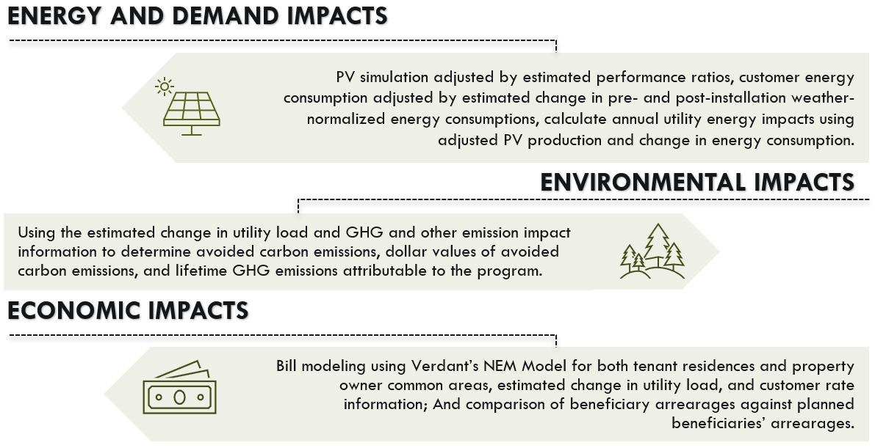

#### PV Production

We anticipate that approximately 265 projects[22] will be installed by the end of 2025, with many of these having a full year of metered PV performance data. For these projects we will compare metered performance data to simulated PV generation data that uses actual weather. Results will inform the simulation estimates for the other planned projects not yet installed. The PV production analysis will utilize the following steps highlighted below in Figure 2‑2.

Figure ‑: PV Production Analysis

* **Simulations of installed system performance will be developed u**sing system characteristics from the program tracking data and actual weather. Like in our second triennial evaluation, the simulation will use *pvlib python,* a python-based, community developed toolbox that provides a set of functions and classes for simulating the performance of photovoltaic energy systems and accomplishing related tasks.[23] Verdant will use historical weather data available from CALMAC to simulate performance of the systems based on actual weather data.[24]
* **Develop PV performance ratios using t**he actual metered PV generation compared to the simulated generation based on actual weather. The PV-ratio represents a month-hour ratio accounting for the differences between observed generation and simulated results. Careful analysis of the performance ratio (metered/simulated generation) can provide actionable insights into the drivers of performance. Variances in configuration and system availability can lead to performance that deviates from expectations. These comparisons will provide a more reliable audit of system performance than a site visit and have the benefit of being substantially more cost effective. Some details of the analyses from these comparisons will include:
* **Calculate forecasted performance of both installed and planned systems.** This simulation will mirror the simulations that the Verdant team performed for the prior SOMAH evaluation. The Verdant team will use the *pvlib python* model with typical weather produced by CALMAC. To estimate expected production in a typical year, the simulated production for all systems will be adjusted by the performance ratios described above. This will ensure that the typical year simulations for installed and planned systems better match evaluated real-world generation.
* **Leverage PA Outreach to Help Inform Differences Between Simulated and Actual Output.** The SOMAH PA is now notifying property owners and contractors for systems that are underperforming by at least 10%. We will leverage any data collected from the SOMAH PA’s communications with system owners and contractors of underperforming systems to help us better understand the observed performance issues. This will allow us to identify the root causes for poorly performing systems and provide recommendations to ensure system optimization.

**Key Results:** Performance ratios comparing actual to expected generation; Adjusted PV production estimates for all SOMAH projects.

#### Customer Electricity Consumption

Verdant staff have found that customer energy consumption often increases following the installation of solar. However, the prior SOMAH evaluation did not find a significant increase in tenant electricity consumption after the installation of solar PV, with PG&E and SDG&E customers showing a decrease in electricity consumption and SCE customers showing a small 3.4% increase. It is unclear if the findings from the customer electricity consumption analysis have more to do with the timing of the last evaluation relative to the COVID-19 pandemic, or if SOMAH beneficiaries do not behave similar to single family PV customers. SOMAH beneficiaries receive their benefits through the VNEM structure; therefore, they are less directly involved in the project’s development and their economic situation likely differs from that of the typical residential PV owner. On the other hand, SOMAH does provide PV bill credits that could lead beneficiaries to increase their energy consumption.

If beneficiary customers increase their energy consumption following the installation of the PV systems, there will be a reduction in energy, environmental, and bill savings impacts relative to the assumption of no change in customer energy consumption. Our planned evaluation of customer energy usage pre- and post-installation will allow us to analyze the behavior of customers with installed systems to determine what changes, if any, can be expected in energy consumption of future beneficiaries after their systems are installed. The customer energy consumption analysis will include the following steps in Figure 2‑3.

Figure ‑: Customer Energy Analysis Steps

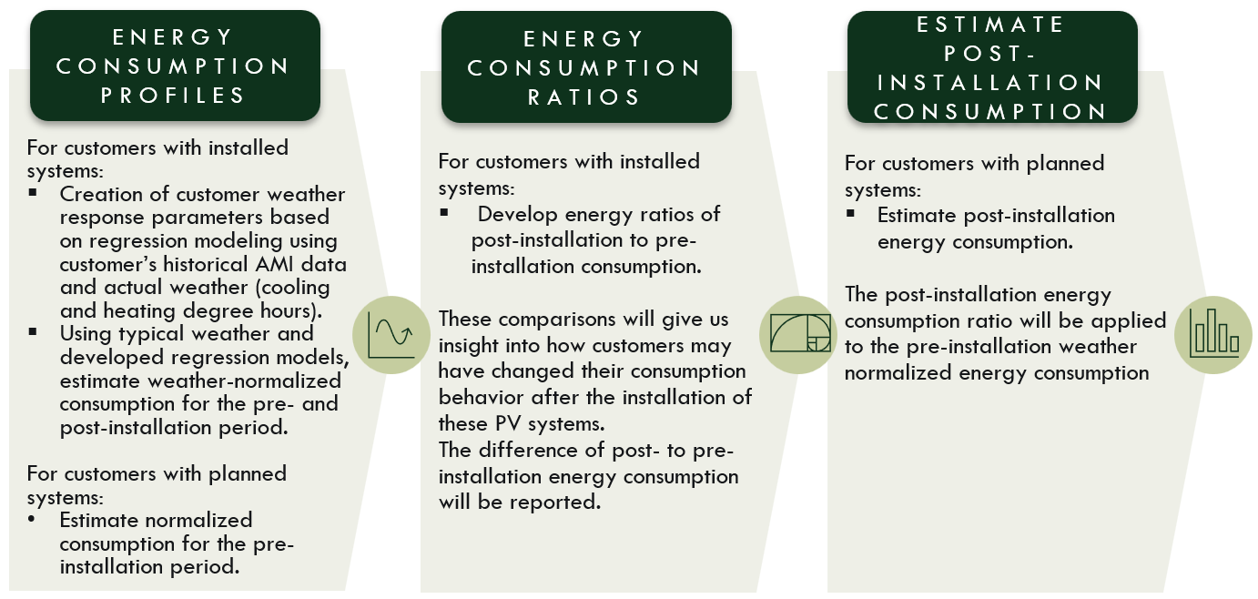

If beneficiary customers with installed systems do not change their electricity consumption following the receipt of the VNEM credits, the evaluation will assume that customers with planned systems maintain their pre-installation energy consumption.

**Key results:** Comparison of pre- to post-installation electricity consumption; Adjusted customer consumption estimates for all customers with SOMAH planned and installed projects.

#### Utility Energy Impacts

Verdant will calculate customer’s change in utility load using the PV performance ratio adjusted PV production, VNEM allocations from program tracking data, and weather normalized estimate of energy consumption change due to the participation in VNEM.

$$∆Utility kWh_{i}=VNEM_{i}*PVR_{IOU_{mo}}*kWhPV_{i}+ ∆kWh_{i}$$

Where,

|  |  |
| --- | --- |
| $$∆Utility kWh_{i}$$ | Is the change in utility load for customer *i* |
| $$VNEM_{i}$$ | Is the VNEM allocation share for customer *i* |
| PVRIOUmo | Is the PV performance ratio that adjusts simulated performance to account for evaluated performance results. This ratio would vary by IOU and by month. |
| $$kWhPV_{i}$$ | Is the simulated typical performance for the PV system associated with customer *i* |
| $$∆kWh_{i}$$ | Is the change in customer *i*’s electricity consumption following the system installation[25] |

The annual utility electrical load reduction will be reported, at a minimum, by IOU. The team will collaborate with the CPUC PM and SOMAH PAs to determine additional levels of reporting.

****The estimated utility electrical load reduction 8760 will be used to calculate **demand impacts** during hours of CAISO and IOU peak demands. We will analyze peak demand over the top 100 peak hours[26] to provide insight into how SOMAH projects impact the grid during the hours of highest load. The top hours will be obtained from the CAISO OASIS website.

**Key results:** annual utility load reduction, peak demand impact

#### Environmental Impacts

The assessed environmental impacts will be based on the evaluated energy impacts described above.

* **The team will use the** marginal carbon dioxide emissions data developed by WattTime as part of the Self-Generation Incentive Program GHG signal (<http://sgipsignal.com>) to **estimate the avoided carbon emissions.** Carbon dioxide emission impacts will be calculated as the avoided emissions that would have occurred in the absence of the program. The hourly marginal emissions rates and the hourly utility electrical load reduction estimates will be combined to estimate avoided emissions in metric tons of carbon dioxide, using data from each year, 2023-2025.
* The **monetary value** **of the change in emissions** will be calculated applying the value of GHGs from the California avoided cost calculator.
* **We will estimate the lifetime GHG emissions reductions attributable to the program during 2025** using the California Air Resource Board (CARB) GHG benefits estimation tool.

**Key results**: estimates of the first year avoided carbon emissions, the lifetime GHG emissions reductions, and the monetary value of emission reductions.

#### Economic Impacts

The program’s economic impacts will be estimated in several different ways, including customer bill changes, impact on bill arrearages, and CARE budget impacts. **Verdant will use two approaches to estimate the program’s bill credits**. The first approach, a utility bill analysis, will compare the actual pre- and post-installation utility bills. This approach will assess changes in pre and post installation bills using actual rates and holding rates constant at their pre-installation values. This approach, however, does not account for changes in weather and how weather can impact customer consumption and PV production.

The second approach will develop calculated bill impacts using typical-weather PV simulation models to estimate PV energy production. This approach will incorporate performance ratios (to account for average observed PV performance), VNEM allocations, typical-weather PV simulations, and weather-normalized energy consumption to calculate the energy impacts for each tenant and common area. This approach accounts for weather-normalized consumption and production as well as average system performance at the utility-level, but it does not account for the site-specific system performance like the utility bill analysis.

Figure ‑: Bill Impact Measurements

The utility bill analysis requires a full year of pre- and post- installation utility bills, limiting the application of this approach to projects that are installed and where their tenants have been receiving bill credits for a full year. The second approach, calculated impacts, can be applied to systems with a year of pre- and post-installation bills, those that do not have a full year of bill credits, and those in the planning phase. Bill impacts will be reported in both dollars saved and kwh of utility energy reduced. Where possible, bill impacts will be reported by IOU, climate zone, property size, DAC property status, CARE participation, and system ownership.

In addition to bill credits, Verdant will **assess the impact of program participation on customer arrearages**. For beneficiaries with installed systems, we will compare customers’ bill arrearages in the pre- and post-installation period. This analysis will also use the arrearages of customers with planned systems as a non-participant control group, comparing how the pre- and post-installation arrearages of customers with installed systems differ from those for customers with planned, but not yet installed systems.

Finally, we will calculate the program’s impact on the **California Alternative Rates for Energy (CARE) program budget**. For customers on CARE, the Verdant team will use the estimated bill savings (from the second measurement described above) and CARE subsidy to calculate the reduction in the CARE program subsidy for these customers. During the prior evaluation, Verdant found that CARE participants, on average, saw a 60% reduction on their monthly electrical bill, resulting in an $800,000 savings to the 2022 CARE Budget.

#### Key Deliverables

* **Energy Impacts:** Estimates of PV production, changes in energy consumption and utility energy and demand impacts.
* **Environmental Impacts:** Estimates of the first year, life-cycle, and monetary value of emissions reductions.
* **Economics Impacts:** Estimates of customer bill impacts, observed changes in arrearages, and reductions in the CARE subsidy.

## Cost-Effectiveness Assessment

The cost-effectiveness of the SOMAH Program will be estimated using the format and content requirements of the 2001 CPUC California Standard Practice Manual for performing Economic Analysis of Demand-Side Programs and Projects. Cost-effectiveness will be quantified using the total resource cost test (TRC), the societal cost test (SCT), and the ratepayer impact measure test (RIM). Verdant will use our publicly vetted cost-effectiveness model to estimate SOMAH’s cost-effectiveness. We will work with the CPUC to determine the appropriate discount rates to use for these tests and to determine the non-energy impacts (NEI) and GHG adders to include in the SCT.

Table 2‑3: Standard Practice Manual Cost-Effectiveness Tests

|  |  |  |
| --- | --- | --- |
| **SPM Test** | **Cost** | **Benefit** |
| TRC | Program Admin Costs, Measure Costs | Avoided Costs, Federal Tax Credits |
| SCT | Program Admin Costs, Measure Costs | Avoided Costs, Federal Tax Credits, GHG Adder, NEI |
| RIM | Program Admin Costs, Reduced Revenue (bill savings – reduced CARE subsidy), Incentive Costs | Avoided Costs |

The Inflation Reduction Act (IRA), passed in 2022, has led to substantial changes to the Federal Investment Tax Credit (ITC) for expenses invested in renewable energy. The IRA reinstated the 30% basic ITC for solar systems installed from 2022 to 2032. The ITC was also expanded to include several bonus credits and to allow for direct or elective pay for nonprofits and other tax-exempt entities (municipalities and tribal governments). The updated ITC includes six different bonus credits, four of which are associated with low-income communities. Projects can only apply for one of the four low-income community bonus credits. The other two bonus credits are stackable. The combination of the basic, low-income, and stackable credits could raise the value of the ITC up to 70% of the eligible costs of the project. The four low-income bonus ITC credits are:

* 10% bonus for projects located in a low-income community
* 10% bonus for projects located on tribal lands
* 20% bonus for projects classified as qualified low-income residential building projects where the financial benefits of solar production are allocated equitably among the residents
* 20% bonus for projects that are classified as qualified low-income economic benefit projects.

The two stackable bonus credits are:

* 10% bonus for projects located in an “energy community”[27]
* 10% bonus for projects meeting domestic content or manufacturer requirements.

The direct or elective pay for nonprofits or other tax-exempt entities allows these entities to receive a payment reimbursement equal to the full value of the ITC and applicable bonus credits.

The updated ITC with bonus credits and the direct/elective payment opportunity are likely to have a substantial impact on project and program cost effectiveness for the TRC and the SCT. It is critical to understand how the expanded ITC and direct/elective payment options are being utilized by program participants and market actors. In-depth interviews with these stakeholders will inform how these new benefits are incorporated into the cost-effectiveness analysis.

****The avoided cost benefits will be calculated using the SOMAH program’s estimated energy impacts and the California avoided costs. For the RIM test, the estimate of reduced utility revenue will include the estimated beneficiary tenant and common area bill savings and an estimate of the reduction in CARE subsidies attributable to SOMAH.

**Key results**: Cost and benefits from multiple points of view and cost-effectiveness values.

#### Key Deliverables

* The final report will present the Cost-Effectiveness Metrics, including the costs and benefits from multiple points of view and three of the Standard Practice Manual tests (TRC, RIM, and SCT).

## Program Administration Assessment

SOMAH Program Administration Spending as of December 31, 2024, was just over $50M[28] and has averaged roughly $8.5M a year since the program launched in July 2019. During this same period the program has paid out roughly $90M in incentive payments (including Progress Payments). As shown in the figure below, from 2020 through 2024[29] the majority of SOMAH program administration spending was on Program Administration (which included tasks such as general program administration, application processing, program reporting, database management, and onsite field verifications).

Figure ‑: Program Administration Spending by Budget Category, 2020 through 2024

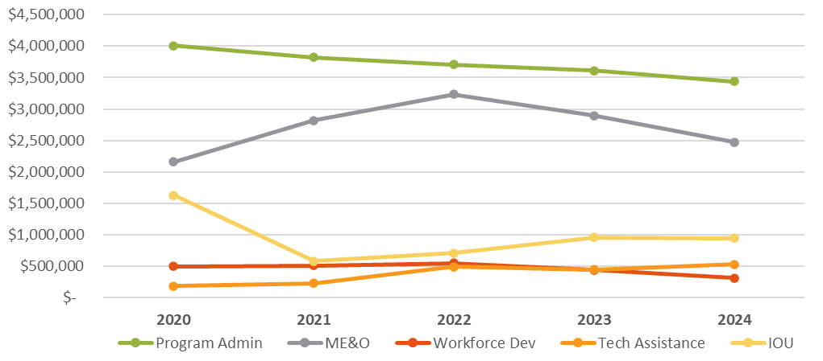

The primary research objectives of the Program Administration assessment are to:

* Evaluate whether SOMAH’s Program Administration efforts are in alignment with, and supportive of, the goals of the SOMAH Program,
* Assess whether SOMAH’s ME&O strategy has been successful in its goal to increase customer participation in SOMAH,
* Determine if SOMAH is on-track to stay below the program’s administrative spending cap of 10%, and
* Assess progress made by the SOMAH PA and IOUs to implement prior evaluation recommendations regarding program spending, ME&O activities, and CBO roles and activities.

Below is the approach we will use to conduct this assessment and the data requirements.

* **Program Administrative Spending Assessment**
* Request program spending data from the SOMAH PA and utilize Semi-Annual Expense Reports to assess program expenditures and uncommitted balances by program.
* Analyze SOMAH monthly spending data from the program’s inception through the end of 2025 to provide a longitudinal summary of administrative spending by entity (four SOMAH PA members, five IOUs, CPUC) and expense category (Admin, ME&O, WFD, TA).
* Analysis of program spending data in conjunction with program tracking data to estimate the average cost of processing an application.
* Based on an in-depth review of program spending to date, spending trend by program year, and remaining program budget, determine whether SOMAH is on-track to stay below the 10% administrative spending cap by the end of the program (in 2032).
* **Marketing, Education, and Outreach Activities**
* Review SOMAH’s ME&O plans from 2020 to 2025 and conduct IDIs with the SOMAH PA to clearly document the activities, trends, and primary challenges of SOMAH’s marketing efforts over the past 5 years. Assess the effectiveness of the ME&O activities to build a robust project pipeline.
* Conduct IDIs and web surveys with participating and non-participating contractors and property owners to determine the effectiveness of SOMAH’s ME&O strategy to increase SOMAH awareness, consideration, and participation amongst eligible contractors and property owners.
* Interview CBOs currently engaging with the program to understand their roles and objectives. Assess the diversity and experience of the CBOs and the effectiveness of their activities towards achieving their objectives (based on primary data collection with property owners and tenants).
* **Assessment of Progress made on Prior Evaluation Recommendations (Vendor Assessment RTR)**
* Review and assess the SOMAH PA’s progress addressing the recommendations documented within the SOMAH Vendor Assessment RTR, such as: 1) Reduce the cost/burden and increase the accuracy of quarterly forecasts by reducing forecast granularity, 2) Improve the readiness and effectiveness of CBO’s outreach activities by increasing the training and support provided to them.
* Identify and provide additional recommendations where program spending should be closely monitored and/or adjusted to increase program participation and improve program outcomes.

#### Key Deliverables

* The final report will document all findings from the Program Administration Assessment, including a longitudinal summary of program implementation costs by program budget category, entity and expense category. It will also present the trends, challenges, and effectiveness of SOMAH’s ME&O activities since the program was implemented and provide recommendations for continued program improvement.

# 

# Project Timeline

The SOMAH evaluation study will be completed and delivered to the CPUC Energy Division by June 1, 2026. Below we provide an overview of the interim milestones leading up to the conclusion of the evaluation

* **Research Plan and Webinar**:
  + Draft research plan released to public on February 14, 2025
  + Public webinar on research plan, February 24, 2025
  + Comments due on research plan, March 6, 2025
  + Final research plan release to public, March 14, 2025
* **Data Collection**
  + IDIs – Mid-March through December 2025
  + Surveys – Mid-March through December 2025
  + AMI, Billing, and PV Data –
    - Request 1: Data through end of March 2025
    - Request 2: Data from April 2025 – September 2025
  + Program Tracking Data – frozen as of December 31, 2025
* **Analysis** of collected data and study assessments, through Mid-March 2026
* **Draft Report** released to public, by April 15, 2026
* **Public webinar** on draft report, by April 30, 2026
* **Final Report**, June 1, 2026

1. <http://docs.cpuc.ca.gov/PublishedDocs/Published/G000/M201/K940/201940057.pdf>
2. <https://leginfo.legislature.ca.gov/faces/billTextClient.xhtml?bill_id=201520160AB693>
3. The program was extended through December 31, 2032, by SB 355.
4. Based on a CalEnviroScreen score in the top 25% of census tracts statewide.
5. SOMAH applications as of 12/31/2022 (2nd report) versus 1/31/2025 (current).
6. Verdant staff’s 2021 evaluation of the California Solar Initiative found that residential electricity consumption increased by 7.2% in the first year following solar installation. However, our Second Triennial SOMAH evaluation did not find a significant increase in tenant consumption for SOMAH participants.
7. Decision 24-11-006 directed each IOU to submit a Tier 1 Primary Data Collection advice letter.
8. https://www.calmac.org/weather.asp
9. http://oasis.caiso.com/mrioasis/logon.do
10. https://sgipsignal.com
11. https://www.cpuc.ca.gov/dercosteffectiveness
12. SOMAH Semiannual Progress Report, Reporting Period July 1, 2024 – December 31, 2024.
13. Based on DGStats data as of January 31, 2025. DGStats does not include information on subcontractors participating in the program.
14. This data will be used to obtain job trainee contact information for the job trainee surveys described below.
15. Program data may also be requested for market rate programs if interviews with IOUs, web surveys with tenants, or our review of SOMAH program materials indicate there is a high likelihood that SOMAH tenants are participating in IOU sponsored market rate programs
16. Some of the planned evaluation surveying activities were dropped from the second triennial evaluation due to overlaps with the SOMAH PAs research activities (namely tenant and job trainee surveys). For this evaluation, our team plans to conduct surveys with these populations but will ensure close coordination with the SOMAH PA to ensure surveyed populations are not overly burdened by our research.
17. The SOMAH PA conducted a Liberty Utilities and PacifiCorp Contractor Analysis in Q4 of 2023 to identify contractors located within a 50-mile radius of Liberty or PacifiCorp eligible properties.
18. SOMAH income qualification now includes properties where 66% of HH (rather than 80% of HH) must have incomes below 80% of AMI (rather than 60% of AMI).
19. Decision D.24-11-006 ordered that the tenant education requirements adopted in Resolution E-4987 are no longer a requirement for new SOMAH applicants. This change is anticipated to take effect in early 2025.
20. The Incentive Claim Package requires that a Job Training Affidavit be submitted which includes contact information of the job trainee who worked on the project, as well as the hours they worked, the wages they were paid and the types of tasks they completed.
21. The SOMAH website has a list of stackable programs that property owners and tenants can explore to help finance other energy efficiency upgrades or offset the cost of installing EV infrastructure at MF properties. <https://calsomah.org/stackable-programs>
22. As of January 2025, there are 248 completed SOMAH projects.
23. Anderson, K., Hansen, C., Holmgren, W., Jensen, A., Mikofski, M., and Driesse, A. “pvlib python: 2023 project update.” Journal of Open-Source Software, 8(92), 5994, (2023). [DOI: 10.21105/joss.05994](http://dx.doi.org/10.21105/joss.05994).
24. CALMAC contains historical and typical weather files for 127 California weather stations.
25. For customers with installed systems, the change in energy consumption is the change in their weather normalized pre- and post-installed electricity consumption. For customers with planned systems, the change in energy consumption is their pre-installed weather normalized electricity consumption adjusted by the evaluated energy ratio.
26. The Top 100 hours is a metric used by the CEC to reflect the System Net Peak Hours.
27. There are multiple approaches for a facility being qualified as an “energy community” including being in a metropolitan or non-metropolitan statistical area which has an unemployment rate above the national average in the previous year.
28. Per SOMAH’s Semi-Annual Expense Report (SAER) dated December 31, 2024 (which includes spending through from 2018 through 12/31/2024) and includes IOU and SOMAH evaluation expenses.
29. This spending in 2019 was removed from this figure as it was only available for a partial program year.